Writing Algorithms
When writing Algorithms you can either write them using a Flowchart or Pseudo Code
When using a flowchart these are the standard symbols:
Decision
Shows Data Flow
Input/Output
Process

Examples of Sequence, Selection and Loops in Flowcharts
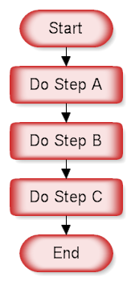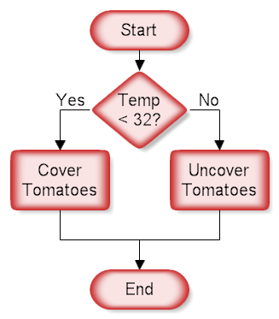
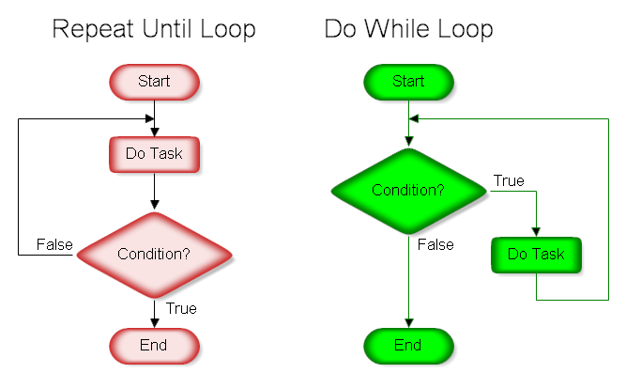

Standard Key Words to use in Pseudo Code

Technique | Example
Selection/Conditional Statement | IF condition THEN  true alternative  ELSE  false alternative  ENDIF
Iteration/Loops | FOR i to/in …  statements to carry out  END FOR  WHILE condition THEN  statements to carry out  END WHILE  REPEAT statement UNTILL …
Operators | > Greater Than  < Less Than  >= Greater than or equal to  <= Less than or equal to  == Equal To  = Equals  != not equal to
Input and Output | INPUT….  OUTPUT…
Function/Procedure | PROCEDURE name  END PROCEDURE  FUNTION name  END FUNTION

